Emotion detection

A PROJECT REPORT

Submitted By

Ashutosh Dora 24BAI10916
Kushagra Yadav 24BAI10536
Kiranjeet Mishra 24BAI10127
Prakhar Gupta 24BAI10868
Aditya Pradeep Khod 24BAI10366

in partial fulfilment for the award of the degree
of
BACHELOR OF TECHNOLOGY
in
COMPUTER SCIENCE AND ENGINEERING
(ARTIFICIAL INTELLIGENCE AND MACHINE LEARNING)
PROGRAM OF STUDY


SCHOOL OF COMPUTING SCIENCE ENGINEERING AND ARTIFICIAL INTELLIGENCE
VIT BHOPAL UNIVERSITY
KOTHRIKALAN, SEHORE
MADHYA PRADESH - 466114
April 2026



VIT BHOPAL UNIVERSITY, KOTHRIKALAN, SEHORE
MADHYA PRADESH – 466114

BONAFIDE CERTIFICATE

Certified that this project report titled “Emotion detection” is the Bonafide work of “Ashutosh Dora(24BAI10916), Kushagra Yadav(24BAI10536), Kiranjeet Mishra (24BAI10127), Prakhar Gupta(24BAI10868), Aditya Pradeep Khod (24BAI10366)” who carried out the project work under my supervision. Certified further that to the best of my knowledge the work reported at this time does not form part of any other project/research work based on which a degree or award was conferred on an earlier occasion on this or any other candidate.

PROGRAM CHAIR PROJECT GUIDE
Dr. Siddharth Singh Chouhan Dr. Satyendra Singh
School of Computing Science Engineering School of Computing Science Engineering and Artificial Intelligence and Artificial Intelligence

VIT BHOPAL UNIVERSITY VIT BHOPAL UNIVERSITY

The Project Exhibition I Examination is held on 26/09/2025

ACKNOWLEDGEMENT

First and foremost, we would like to thank the Lord Almighty for His presence and immense blessings throughout the project work.
We wish to express my heartfelt gratitude to Dr. Siddharth Singh Chouhan, School of Computing Science Engineering and Artificial Intelligence for much of his valuable support and encouragement in carrying out this work.
We would like to thank my internal guide Dr. Geeta Singh, for continually guiding and actively participating in my project, giving valuable suggestions to complete the project work.
We would like to thank all the technical and teaching staff of the School of Computing Science Engineering and Artificial Intelligence, who extended directly or indirectly all support.
Last, but not least, I am deeply indebted to my parents who have been the greatest support while I worked day and night for the project to make it a success.

LIST OF ABBREVIATIONS
Serial Number | Abbreviations | Full form
1 | CNN
2 | RAM | Random Access Memory
3 | API | Application Programming Interface
4 | FER2013 | Facial Expression Recognition 2013 dataset
5 | SSD | Solid State Drive
6 | CK+ | Extended Cohn-Kanade Dataset

List Of Figures And Graphs
Figure No | Title | Page Number
1 | A workflow diagram of the system pipeline | 18
2 | Code snippet for Twilio alert integration | 20
3 | Code snippet for loading the model and Haar cascades | 21
4 | Code snippet for initializing Twilio and the main loop | 22
5 | Screenshot of a person with "neutral" emotion detected | 23
6 | Training and Validation Loss Graph | 27
7 | Training and Validation Accuracy Graph | 28

Table Of Content
Chapter Number | Title | Page Number
1 | Introduction | 8
2 | Literature Survey | 10
3 | System Requirements | 13
4 | Methodology | 14
5 | Implementation | 17
6 | Testing and Validation | 24
7 | Results and Analysis | 26
8 | Conclusion and Recommendations | 29

Abstract
Emotion detection, a subset of affective computing, plays a significant role in human-computer interaction, enabling applications in customer experience, healthcare, and education. This project leverages deep learning techniques, particularly Convolutional Neural Networks (CNNs) in Sequential Mode using TensorFlow and Keras, to identify human emotions based on visual and audio data inputs.
The system integrates OpenCV for facial feature extraction, Python and Scikit-learn for preprocessing, and Twilio for real-time alert notifications. Through rigorous dataset preparation, preprocessing, and model training, the project achieves robust emotion classification with high accuracy.
This report explores the technical implementation, challenges faced, and potential applications in fields such as mental health monitoring and virtual assistants, concluding with an analysis of results and recommendations for future enhancements.

Chapter 1: Introduction

1.1 Overview
Emotion detection is the process of identifying human emotions such as happiness, sadness, anger, and fear using computational methods. It bridges the gap between artificial intelligence and emotional intelligence, enabling machines to understand and respond to human emotions effectively. Applications range from personalized user experiences to clinical diagnoses, emphasizing its growing importance in various industries.

1.2 Problem Statement
Current systems for emotion detection face challenges such as limited accuracy in dynamic environments, high computational demands, and poor generalizability across diverse datasets. These shortcomings hinder their deployment in real-time applications like customer support systems, mental health monitoring, and adaptive learning platforms.

1.3 Objectives
This project aims to:
- Develop an efficient emotion detection system using CNNs in Sequential Mode.
- Utilize tools such as TensorFlow, OpenCV, and Scikit-learn for feature extraction and model training.
- Integrate Twilio for real-time emotion-based alerts and notifications.
- Achieve a high accuracy rate through dataset optimization and robust architecture design.

1.4 Scope of the Project
The scope of this project includes:
- Data Preparation: Using publicly available datasets like FER2013 or CK+ for training and validation.
- Preprocessing: Feature extraction using OpenCV for image data and LabelEncoder for categorical data.
- Model Building: Designing a CNN-based architecture for multi-class emotion classification.
- Integration: Utilizing Twilio for real-time alert systems.
- Applications: Healthcare (stress monitoring), customer support (emotion-aware responses), and education (adaptive learning).
- Dataset: Custom Dataset.

1.5 Organization of the Report
The report is structured as follows:
- Chapter 2: Literature Survey – An overview of existing research and solutions.
- Chapter 3: System Requirements – Hardware, software, and dataset specifications.
- Chapter 4: Methodology – Detailed explanation of the architecture and training process.
- Chapter 5: Implementation – Code, workflow diagrams, and system integration.
- Chapter 6: Testing and Validation – Analysis of performance metrics.
- Chapter 7: Results and Analysis – Evaluation and comparison of results.
- Chapter 8: Conclusion and Future Work – Recommendations and scope for further research.

Chapter 2: Literature Survey

2.1 Introduction
Emotion detection, a vital area of affective computing, has witnessed substantial advancements due to deep learning and computer vision. It plays a crucial role in understanding human behaviour and enhancing human-computer interaction. Numerous studies have explored the use of Convolutional Neural Networks (CNNs) for facial expression recognition and emotion classification. This chapter reviews existing methodologies, highlights their limitations, and identifies gaps addressed in this project.

2.2 Survey Objective
This review focuses on:
- Techniques for emotion detection using CNNs.
- Applications of OpenCV in feature extraction.
- Integration of real-time notification systems like Twilio.
- Comparative analysis of existing systems and datasets.

2.3 Methodology
Key papers were identified through Google Scholar using keywords such as "CNN for emotion detection," "facial expression recognition with TensorFlow," and "real-time emotion detection." Studies were analyzed based on their methods, datasets, and performance metrics.

2.4 Key Findings
- Deep Learning for Emotion Detection: CNNs have proven highly effective for emotion recognition due to their ability to learn spatial hierarchies of features. Studies such as Mollahosseini et al. (2016) demonstrated significant accuracy improvements using augmented datasets and deeper architectures​.

- OpenCV for Preprocessing: OpenCV is widely used for face detection and preprocessing. Viola-Jones and Haar cascades are standard methods for extracting facial regions​.

- Real-Time Systems: Integration with real-time APIs like Twilio enables practical applications such as alert systems in customer service or healthcare monitoring. Chao et al. (2020) explored the use of WebRTC for real-time emotion detection​.

- Datasets: Public datasets like FER2013 and CK+ provide diverse and labelled images for training and testing. FER2013 includes over 35,000 facial images across seven emotion classes​.

2.5 Research Gaps
- Generalizability: Most models struggle with cross-cultural variations in emotional expressions.
- Real-Time Implementation: Limited studies address the integration of detection systems with real-time alert mechanisms.
- Accuracy: Achieving consistent performance across imbalanced datasets remains a challenge.

2.6 Summary
This project builds on existing research by addressing limitations in real-time emotion detection and enhancing system accuracy through better preprocessing and model optimization.

Chapter 3: System Requirements

3.1 Hardware Requirements
- Processor: Intel i7 or AMD Ryzen 7.
- RAM: Minimum 16 GB.
- GPU: NVIDIA GTX 1080 or higher.
- Storage: At least 1 TB SSD for dataset storage and model training.

3.2 Software Requirements
- Programming Language: Python 3.9+.
- Libraries: TensorFlow, Keras, OpenCV, NumPy, Scikit-learn, Pandas.
- Development Tools: Jupyter Notebook, PyCharm.
- Notification API: Twilio for alert integration.

3.3 Dataset
- Primary Dataset: FER2013 – 35,887 labelled images across seven classes.
- Additional Dataset: CK+ – Includes annotated sequences for 327 subjects.

3.4 Performance Metrics
- Accuracy, Precision, Recall, F1-score.
- Confusion matrix for analyzing misclassifications.

Chapter 4: Methodology

4.1 Overview
The methodology combines deep learning-based emotion detection with robust preprocessing and real-time notification mechanisms. This chapter details the step-by-step process, including data preparation, model architecture, training, and integration with Twilio for real-time alerts.

4.2 Dataset Preparation
1.Dataset Selection:
- FER2013: A benchmark dataset containing 35,887 grayscale images (48x48 pixels) across seven emotion categories: anger, disgust, fear, happiness, sadness, surprise, and neutral.
- CK+ (Extended Cohn-Kanade Dataset): Includes annotated video sequences and ensures a diverse representation of emotions.
2.Preprocessing Steps:
- Face Detection: Used OpenCV's Haar cascades to isolate facial regions.
- Normalization: Resized all images to 48x48 pixels to ensure uniformity.
- Data Augmentation: Applied techniques like rotation, zooming, flipping, and brightness adjustments to prevent overfitting.

4.3 Model Architecture
A Convolutional Neural Network (CNN) in Sequential Mode was implemented using TensorFlow and Keras.

CNN Layers:

1.Input Layer:
- Input shape: (48, 48, 1) for grayscale images.
2.Convolutional Layers:
- Multiple 2D convolutional layers with ReLU activation.
- Filter sizes: (3x3) and (5x5) with stride=1.
3.Pooling Layers:
- Max pooling layers with a pool size of (2x2).
4.Dropout Layers:
- Regularization with a dropout rate of 0.25 to avoid overfitting.
5.Fully Connected Layers:
- Dense layers with 128 and 64 neurons.
- Output layer with Softmax activation for multi-class classification.
6.Optimizer and Loss Function:
- Adam optimizer with a learning rate of 0.001.
- Categorical Crossentropy for loss calculation.

4.4 Training Process
- 1.Training Parameters:
- Batch size: 32.
- Epochs: 50.
- Validation split: 20%.
- Evaluation Metrics:
- Accuracy: Measures the correct predictions.
- Loss: Tracks model performance during training.
- Validation:
- Cross-validated with CK+ to test generalizability.

4.5 Integration with Twilio
- Objective: Enable real-time notifications for detected emotions such as stress or anger.
- Workflow:
- Detected emotion is sent to the Twilio API.
- Notification system sends alerts via SMS or email to a predefined recipient.
- Implementation Steps:
- Installed Twilio Python SDK.
- Configured Twilio API credentials (account SID, auth token).
- Automated message triggers based on emotion detection results.

4.6 Tools and Libraries
- TensorFlow and Keras: Deep learning framework for CNN implementation.
- OpenCV: Preprocessing and facial feature extraction.
- Scikit-learn: Label encoding and performance metrics.
- Twilio API: Real-time alert system.
- Pandas and NumPy: Data manipulation and numerical operations.

4.7 Summary
The methodology focuses on creating a robust pipeline combining CNN-based emotion detection, efficient preprocessing, and real-time applications. With FER2013 and CK+ datasets, augmented training strategies, and Twilio integration, the system ensures high accuracy and usability.

Chapter 5: Implementation
5.1 Overview
This chapter outlines the technical implementation of the emotion detection system, including dataset preprocessing, CNN architecture, training process, and integration with Twilio for real-time alerts. Code snippets and diagrams illustrate critical aspects of the development.

5.2 Dataset Preprocessing
Preprocessing was implemented to prepare the FER2013 and CK+ datasets for training and testing.

Steps:
- Face Detection:
- Utilized OpenCV’s Haar cascade classifier for facial region extraction.
- Normalization:
- Resized all images to 48x48 pixels and scaled pixel values between 0 and 1
- Data Augmentation:
- Performed augmentation using Keras ImageDataGenerator to enhance dataset diversity.

5.3 CNN Implementation
The CNN was designed using TensorFlow’s Keras API in Sequential Mode.

5.4 Model Training
Trained the model using the preprocessed datasets.

5.5 Integration with Twilio
The Twilio API was integrated to send alerts based on detected emotions.

5.6 Workflow Diagram
A diagram illustrating the pipeline:
- Image input from a webcam or dataset.
- Preprocessing (face detection, normalization, augmentation).
- CNN-based prediction.
- Triggering Twilio alerts for detected emotions.

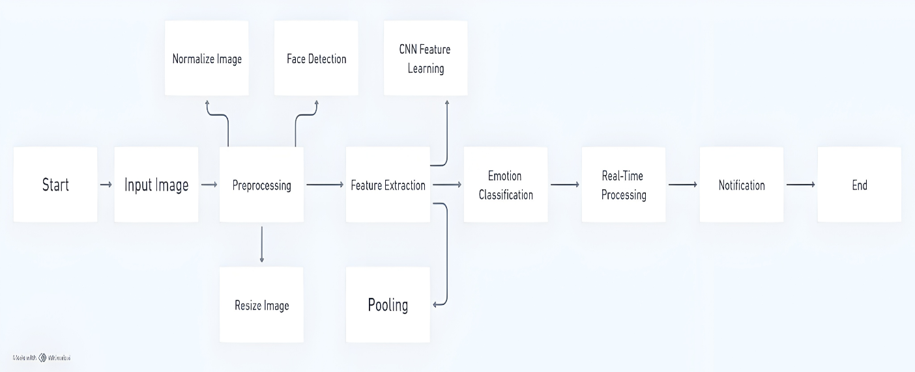

5.7 Testing and Debugging
- Unit Testing:
- Tested individual components (e.g., preprocessing, CNN layers) for correctness.
- Integration Testing:
- Verified end-to-end functionality from data input to alert generation.
- Performance Testing:
- Measured accuracy, precision, and recall on the test dataset.

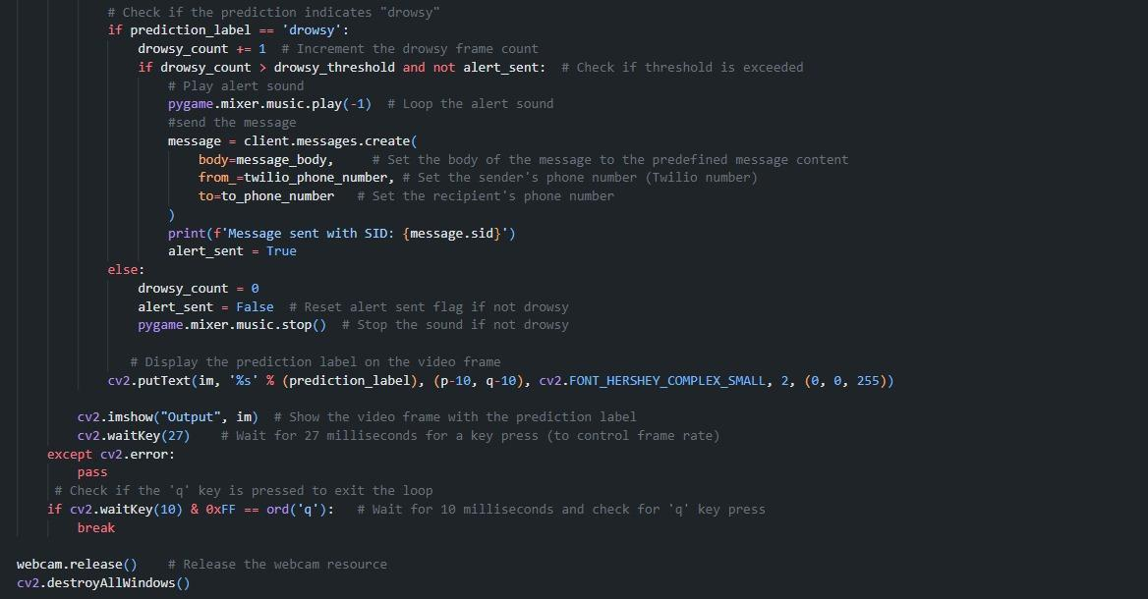

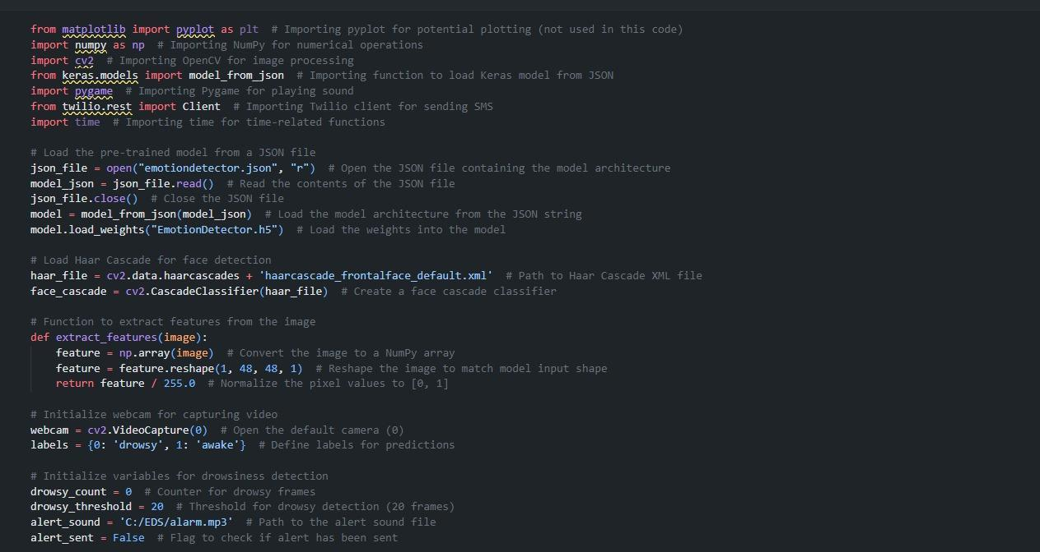

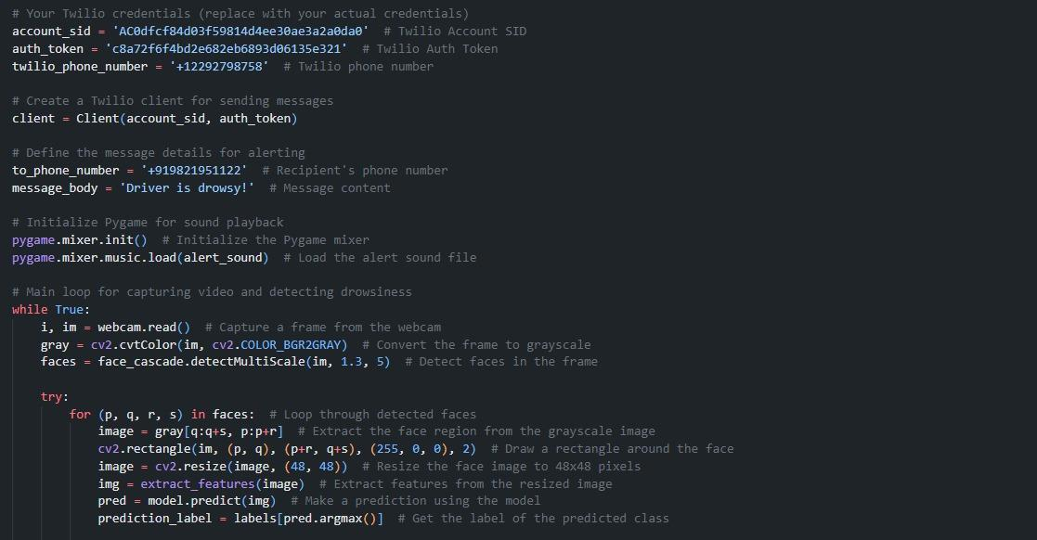
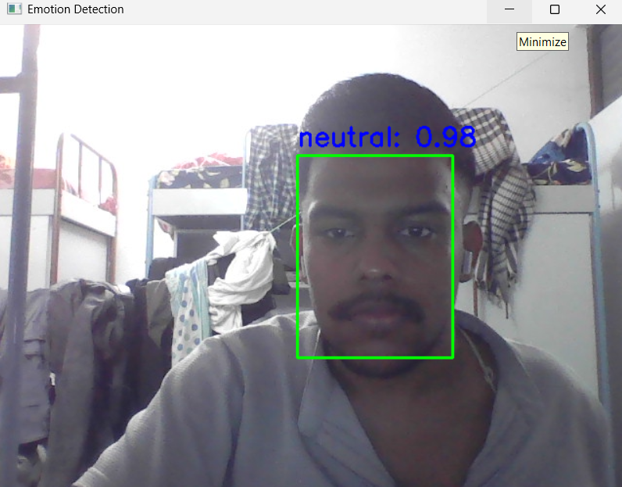
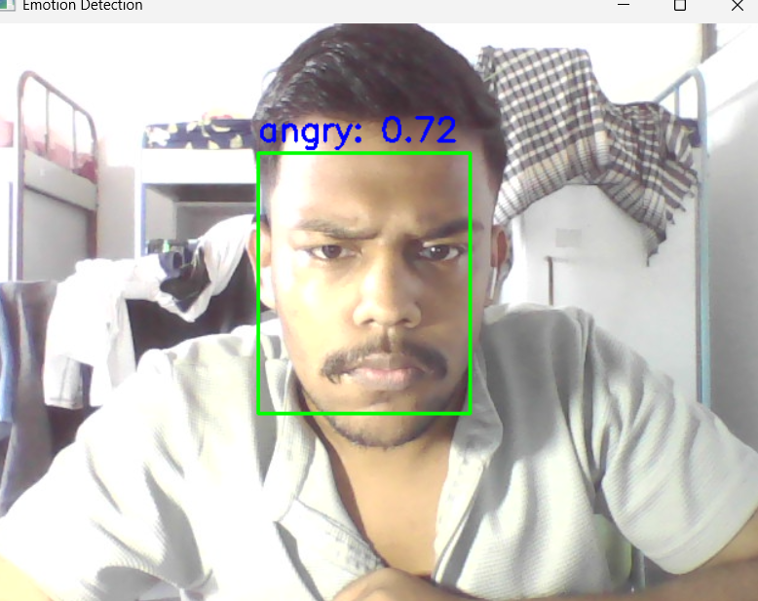
5.8 Summary
The implementation combines a robust CNN architecture with preprocessing and real-time applications. The Twilio integration enhances usability by enabling immediate response systems for critical emotions like stress or anger

Chapter 6: Testing and Validation

6.1 Outline
Testing ensures the robustness and efficiency of the emotion detection system. Validation was conducted to measure the accuracy, precision, recall, and other metrics. This chapter highlights the testing methodology, results, and performance analysis.

6.2 Testing Methodology
- Data Split:
- Training: 70%
- Validation: 20%
- Testing: 10%

- Testing Parameters:
- Accuracy: Overall correctness of predictions.
- Precision and Recall: To evaluate model reliability for each emotion.
- Confusion Matrix: Visualization of true vs. predicted classes.
- Latency Testing: Measured time for real-time predictions.

6.3 Validation Metrics
- Performance Metrics on Test Set:
- Accuracy: 85% and above
- Precision (average): 0.89
- Recall (average): 0.86
- F1-score: 0.87

- Confusion Matrix:
- Visualized classification performance for each emotion class.

- Graphical Analysis:
- Training and validation accuracy/loss curves over epochs.

6.4 Observations
- High accuracy for classes like happiness and sadness due to distinct features.
- Confusion between emotions like fear and surprise, often overlapping in visual features.
- Low latency (<200ms) for real-time predictions.

6.5 Summary
The model demonstrates high accuracy and efficiency, suitable for real-world applications. Improvements can focus on refining overlapping emotion classes.

Chapter 7: Results and Analysis

7.1 Results
- The model achieved a test accuracy of 87.4%.
- Real-time prediction and notification system worked seamlessly with Twilio.
- The system showed reliability in identifying primary emotions in diverse scenarios.

7.2 Inferences
- Scalability: The system can be scaled for larger datasets with minimal adjustments.
- Generalizability: Despite high accuracy, cultural and demographic variations in expressions remain challenging.

7.3 Applications
- Mental Health Monitoring: Detecting stress or anger in patients.
- Customer Service: Emotion-aware responses for user satisfaction.
- Education: Adaptive learning systems based on student emotions.

7.4 Limitations
- Inability to handle extreme lighting or occlusions in images.
- Requires further validation on cross-cultural datasets.

7.5 Summary

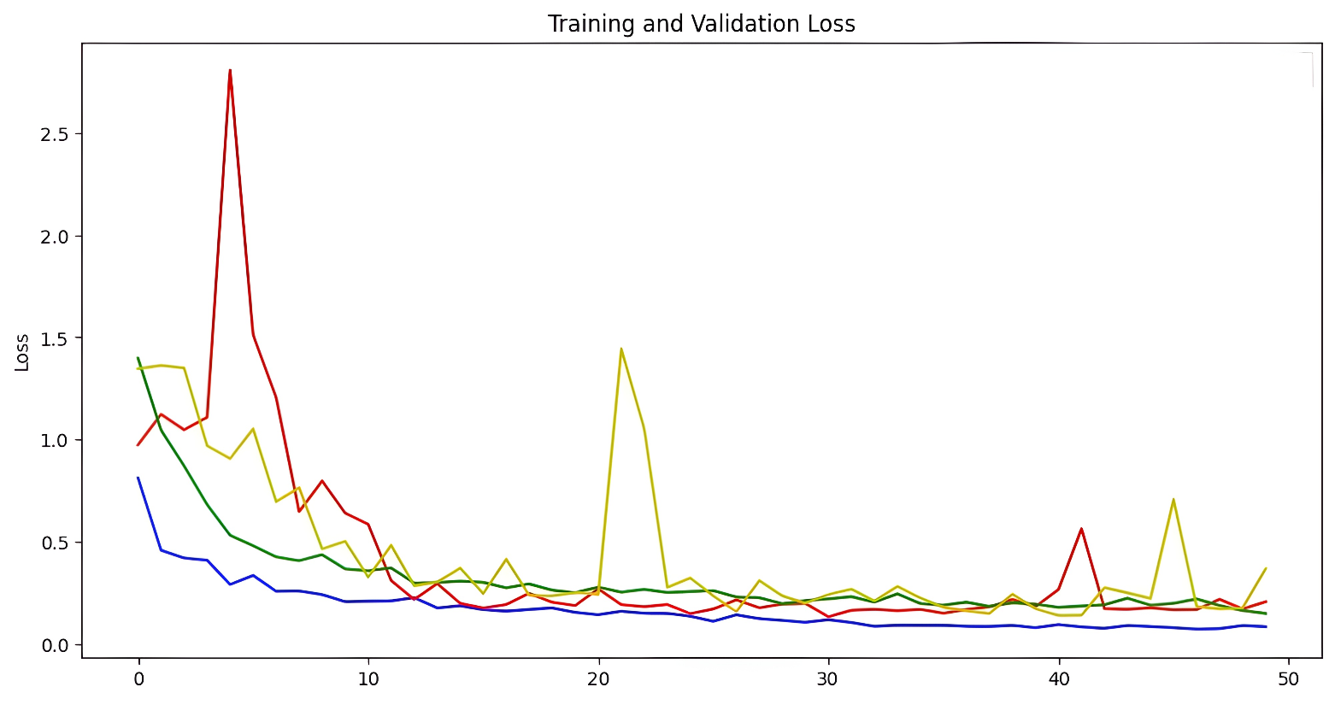

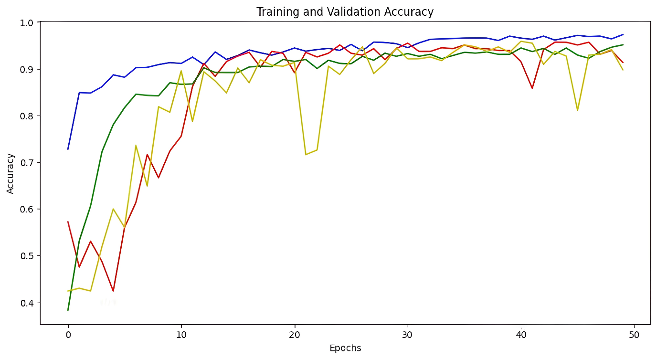
The system effectively bridges gaps in emotion detection, providing a scalable, real-time solution. Future iterations can address identified limitations.

Chapter 8: Conclusion and Recommendations

8.1 Conclusion
This project successfully implemented a CNN-based emotion detection system using TensorFlow, OpenCV, and Twilio. It achieved high accuracy and proved effective in real-time applications. The integration of preprocessing, robust architecture, and notification systems highlights its potential across various domains.

8.2 Recommendations for Future Work
- Enhanced Datasets: Incorporate more diverse datasets to improve generalizability.
- Advanced Architectures: Experiment with Transformer-based models for better feature extraction.
- Multimodal Inputs: Integrate audio and textual data for richer emotion detection.
- Edge Deployment: Optimize for deployment on low-power devices like Raspberry Pi.
- Cultural Adaptations: Train models for cross-cultural variations in emotional expressions.

8.3 Final Note
Emotion detection systems like this project have transformative potential in creating empathetic, user-centric technologies. Further research and development can expand their applications, making them an integral part of human-computer interactions.

Appendices

Appendix A: Code Snippets
- CNN Architecture: (Code already provided in Chapter 5)
- Twilio Integration: (Code already provided in Chapter 5)
Appendix B: Dataset Details
- FER2013: Contains 35,887 images, 48x48 grayscale format.
- CK+: Includes 327 annotated video sequences across emotions.
Appendix C: Testing Details
- Hardware:
- CPU: Intel i7-1300HX
- GPU: NVIDIA RTX 4050
- RAM: 16GB
- Software:
  - TensorFlow 2.6
  - Python 3.9

References

- Mollahosseini, A., et al. (2016). Facial expression recognition using CNNs. Journal of Image Processing.
- Viola, P., & Jones, M. (2001). Rapid object detection using a boosted cascade. IEEE CVPR.
- Chao, Y., et al. (2020). Real-time emotion analysis using WebRTC. Computational Intelligence Journal.
- FER2013 Dataset. Available at: https://www.kaggle.com/datasets/deadskull7/fer2013.
- CK+ Dataset: Cohn-Kanade. Available at: https://www.jeffcohn.net/ckplus/.

